**CHAPTER 1**

**INTRODUCTION**

* 1. **PROBLEM DEFINITION**

In this you can add some more extra features to directly contact with the faculties to clarify their doubts in chat system and students can download the materials. The staff can conduct quizzes in this application.

* 1. **OBJECTIVE OF THE PROJECT**

Admin has full authority of the website to manage students, faculties, question and answers, result, examination, course and events etc. The faculties can upload study materials through online. The students can view uploaded study materials by faculties. The project has individual and group chat feature where students can chat with faculties.

E-learning is a structured course or learning experience delivered electronically; it can also include performance support content. E-learning courses are typically managed and administered via a learning management system .The admin of this site takes care of the activities such as adding and removing of courses, subjects, students and staff members and publishing notices. In the application to provides the contact information for college management.

* 1. **EXISTING SYSTEM**

In the existing system students can communicate with their daily activities. Campus information is not present in the social networking system. The admins can only view the chats in discussion sessions. Students cannot access the study materials and quizzes in the panel. In each degree they don’t have to permission to discuss subject related questions. All students should chat with everyone in one module only.

* + 1. **DRAWBACKS OF EXISTING SYSTEM**
* Students cannot access the study materials and quizzes in the panel.
* Notices cannot be provided in the timeline bar.
* Faculty login panels are not provided.
  1. **PROPOSED SYSTEM**

We studied in depth in previous papers. In that student communicate with their daily activities. We are providing campus information and timeline notices in the application. Admin to control the all activities in the application. Students have permission to access the study materials and quizzes in the panel. In each degree they have a permission to discuss subject related questions. Different modules for student discussion in the application.

* + 1. **ADVANTAGES OF PROPOSED SYSTEM**
* The faculties can upload study materials through online.
* Notices can be provided in the timelines bar.
* Students can access the study materials and quizzes in the panel.

**CHAPTER 2**

**LITERATURE SURVEY**

**Ibrhaim Al-Oqily, Emad Abdallah , and Alaa Abdallah, “Mobile Intra-Campus Student Social Network”[1] :**

This application provides only social network for students. It cannot have separate discussion for each department. There are no instructors for miniaturization. Messages are visible to allstudents.

The system includes several components such as authentication, group manager, profile manager, notification manager, and posts manager. For instance, the group manager is responsible for creating automatic groups to assist the learning process, thus in addition to allowing users to create and manage their own groups, the group manager dynamically creates and manages groups relevant to courses and projects. Moreover, the notification manager, dynamically deliver messages to the targeted users’ groups based on the university registration system.

**Vineet Singh, “A study of Social Network Applications”[2] :**

Social network applications have a major impact on young people and also helped to gain importance in academic life. These tools provides the facility of the social network and it also encourages the process of traditional teaching.

The use of mobile technologies has grown extremely recently and have overtaken the use of personal computers in modern professional and social contexts. The authors argue that these changes will create reasonable conditions for the pedagogical use of mobile technologies based on authentic learning. E-Learning has gained lot of interest mainly for its boundless and convenience ways of learning.

**Dr. mohammadyahya alhamudi“Android Based Student Learning System”[3] :**

In the existing system there are different modules such asactivities due dates, exam alert and discussion notifications. Italso have tutorial tool for students to reduce paper work.

Social network applications have a major impact on young people and also helped to gain importance in academic life. These tools provide the facility of the social network and it also encourages the process of traditional teaching.

**Prabhu T Kannan, Sri vidya, “Academic usage of Social Networking Sites”[4] :**

Social-networking sites are interactive due to the availability of chat rooms, discussion forums, and network-based gaming applications. Therefore, Unlike regular Web sites, online social networks provide a way to connect and have fun with contacts.

Student information is available to administrators across the institution, In which it facilitates planning and coordination. Learning Management System is a software application to share course content and track the progress of individual students.

**CHAPTER 3**

**SYSTEM REQUIREMENTS**

#### 3.1 HARDWARECONFIGURATION

Processor - Intel Pentium or above

RAM - 512MB or above

Hard Disk- 50GB

#### 3.2SOFTWARECONFIGURATION

Operating System - Windows8,8.1,10.

Data Base - MySQL

Server - XAMPP

Front End - HTML, CSS, JavaScript.

Back End - PHP

**3.2.1TECHNICAL DESCRIPTION**

**Steps to Installation of XAMPP**

**XAMPP** is an abbreviation for cross-platform, Apache, MySQL, PHP and Perl, and it allows you to build WordPress site offline, on a local web server on your computer. It is the most popular software package which is used to set up a PHP development environment for web services by providing all the required software components.

**Step1:Download**

In the web browser, visit Apache Friends and download XAMPP installer. It is the most popular software package which is used to set up a PHP development environment for web services by providing all the required software components.

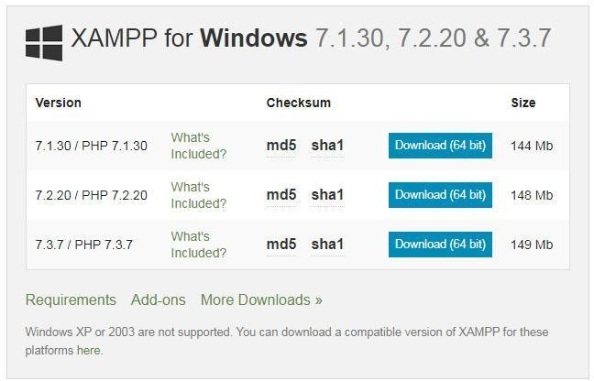

#### Step2: Run the Installer to Install XAMPP

##### XAMPP Setup Wizard

During the installation process, you may come across warning pop-ups. But you would probably click ‘Yes’ to start the installation process. Soon after you click on the downloaded file, the XAMPP setup wizard will open. Now click on the ‘Next’ Button to proceed.

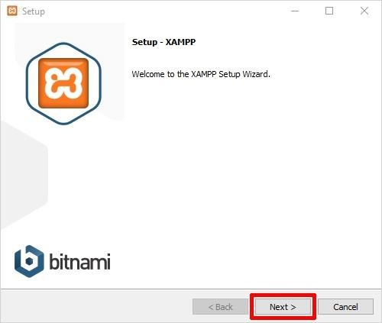

#### 2. Select Components

Next, you need to check the components which you want to install and can uncheck or leaves it is which you don’t want to install. You can see there are a few options which are lightered in color. These are the options which are necessary to run the software and will automatically be -installed. Now click on the ‘Next’ button to continue.

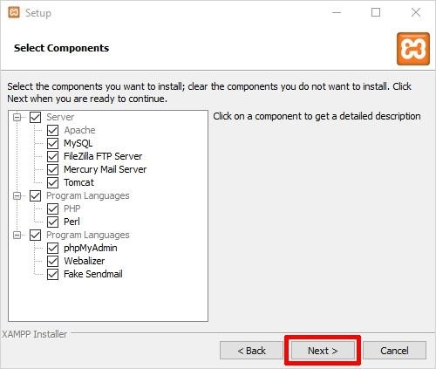

##### **Select Installation Folder**

Now you need to choose the folder where you want to install the XAMPP. You can choose the default location or you can choose any location of your choice and choose the ‘Next’ button to move ahead.

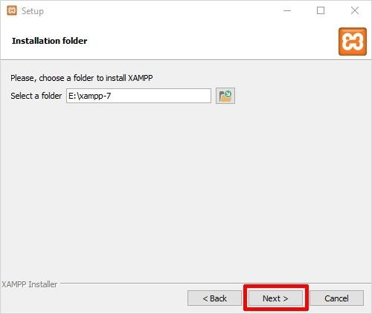

##### **Bitnami for XAMPP**

Now will see a window showing you information about Bitnami. Simply click on the ‘Next’ button to move further. However, if you wish to learn more about the Bitnami, then you may check the box saying ‘Learn more about Bitnami for XAMPP.’ Basically Bitnami is for installing open-source applications i.e., WordPress, Joomlaetcon your newly installed XAMPP.

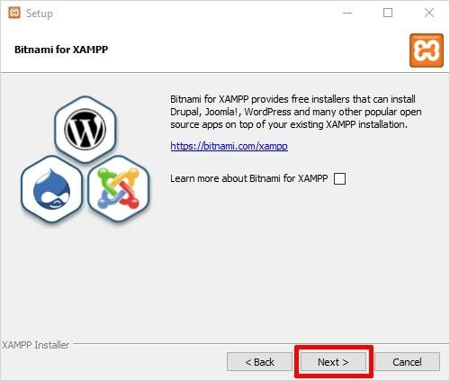

##### **Ready to Install XAMPP**

Now you’ll see another window with a message “Setup is now ready to begin installing XAMPP on your computer” like shown below. You just have to hit the ‘Next’ button to proceed.

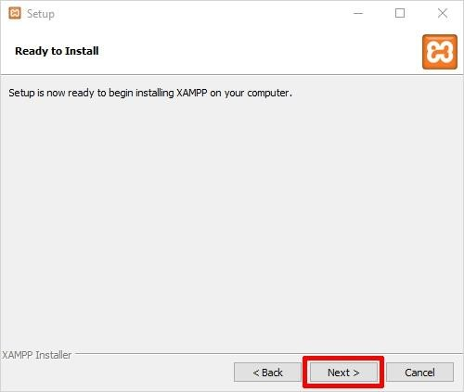

* + - 1. **Welcome to XAMPP Wizard**

Now just be patient and wait for the installation to complete.

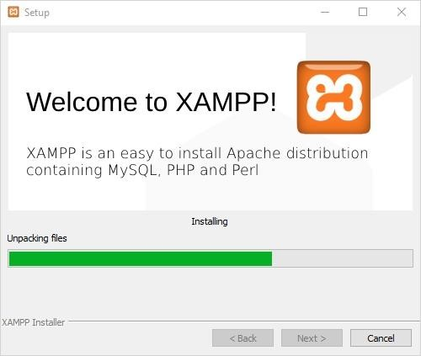

##### **XAMPP Installation Complete**

Once the installation is completed, you will be asked whether you would like to start the control panel now or not, displaying the message “Do you want to start the control panel now? “Check the box and click on the‘ Finish’ button and see if the XAMPP is working fine.

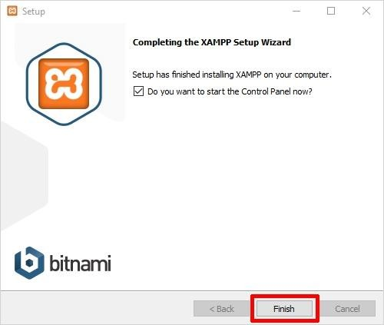

**Step3: Select your XAMPP Install Language**

As soon as you will click on the Finish button in the final step of install XAMPP process, you

will be asked to select the preferred language between English and German. It is up to you

which language you choose. After that click on the ‘Save’ button to confirm your selected

language. As of now, I am choosing the English language

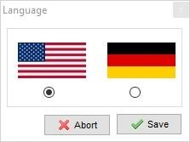

#### Step4: XAMPP is now Installed on Windows, runit

If the entire process of XAMPP installation went correctly, then the control panel would open

smoothly. Now click on the ‘Start’ button corresponding to Apache and MySQL

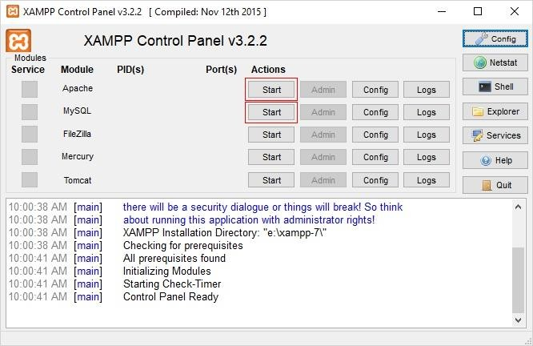

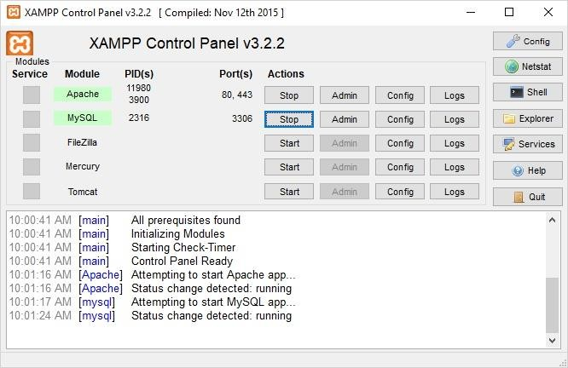

That’s it. You have successfully installed XAMPP on Windows 10. Or say you have successfully installed XAMPP locally. Once you start the modules, you should see their status

turn to green. Whereas, on the right side, you can see the process ID number and port numbers

every module is using. You’re good to go now. Happy Camping!

**CHAPTER 4**

**SYSTEM ANALYSIS**

**4.1. INTRODUCTION**

The aim of this site is to provide a single platform for students and the staff to interact with each other, such as discussing their queries, uploading and viewing the study materials, chatting with each other, attending the quiz provided by the staff members, uploading their messages, images and videos in their timeline, viewing the notices published by the staff members . The admin of this site takes care of the activities such as adding and removing of courses, subjects, students and staff members and publishing notices.

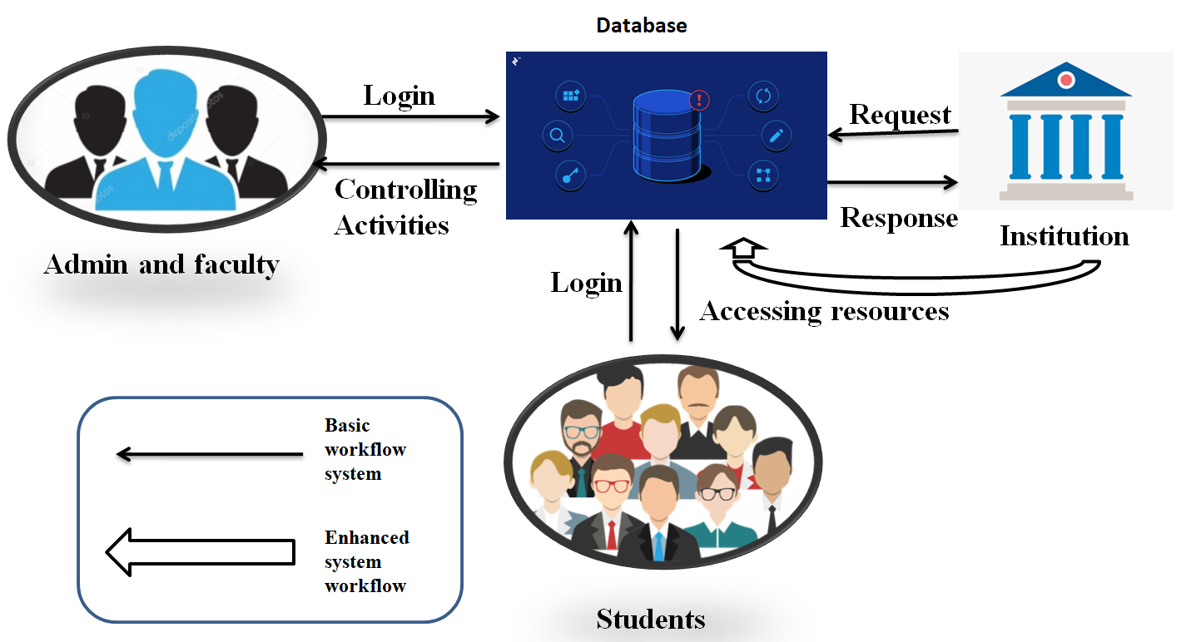

**Figure 4.1: Architecture E-Learning and Information system**

**4.3. SYSTEM MODULES**

**SYSTEM MODULES :**

There are three types of modules are developed in our project :

* Admin and Staff
* Student
* Campus Information

**4.3.1. ADMIN**

The page requires user id and password to start the application. Login is a process by which individual access to a computer system is controlled by identifying and authenticating the user through the cardinalities presented by the user. Admin can add or delete the category, subcategory etc. It contains sub modules they are as follows:

* + - * Add staff
      * Add subjects
      * Add students
      * Add courses
      * Managing activities

**4.3.2 STUDENT**

The students and the staff to interact with each other, such as discussing their queries, uploading and viewing the study materials, chatting with each other, attending the quiz provided by the staff members, uploading their messages, images and videos in their timeline, viewing the notices published by the staff members .

#### FUNCTIONALANDNON-FUNCTIONALREQUIREMENTS:

##### **4.4.1 Functional Requirements:**

* + - * The following are functional requirements of system
      * To implement a user interface on the system
      * User-friendly front-end design using Cascading Style Sheets.
      * Strong authentication while performing various operations.
      * Javascript validations and alerts wherever needed.

##### **4.4.2 Non-Functional Requirements:**

* + - * The following are non-functional requirements of the system:
      * Secure access of confidential data (users ‘details).Syllabised.
      * Better component design to get better performance at peak time.
      * Flexibleservice-basedarchitecturewillbehighlydesirableforfutureextension.

#### 4.5 FEASIBILITY STUDY

The feasibility of the project is analyzed in this phase and business proposal is put forth with every

general plan for the project and some cost estimates. During system analysis the feasibility study of the proposed system is to be carried out. This is to ensure that the proposed system is not a burden to the company. For feasibility analysis, some understanding of the major requirements for the system is essential.

Three key considerations involved in the feasibility analysis are

* + - ECONOMICAL FEASIBILITY
    - TECHNICAL FEASIBILITY
    - OPERATIONAL FEASIBILITY
    - SOCIAL FEASIBILITY

#### 4.6 ECONOMICAL FEASIBILITY:

Economically, this project is completely feasible because it requires no extra financial investment and with respect to time, it’s completely possible to complete this project in 6months. In this step, we verify the proposal which is more economical. We check the financial benefits of the new system with the investment. The new system is economically feasible only when the financial benefits are more than the investments and expenditure. Economic Feasibility determines whether the project goal can be within the resource limits allocated to it or not. It must determine whether it is compulsory to process with the entire project or whether the benefits obtained from the new system are not worth the costs. Financial benefits must be equal or exceed the costs. Our project is economically feasible because the cost of development is very minimal when compared to financial benefits of the application***.***

#### 4.7 TECHNICAL FEASIBILITY

#### In this step, we verify about the proposed systems are technically feasible or not. i.e., all the technologies required to develop the system are available readily or not. Technical Feasibility determines whether the organization has the technology and skills necessary to carry the project and how this should be obtained. The system can be feasible because of the following grounds: All necessary technology exits to develop the system. This system is too flexible and it can be expanded further. This system can give guarantees of accuracy, ease of use, reliability andsecurity of your data. This system can give instant response to inquire

#### 4.8 OPERATIONAL FEASIBILITY

In this step, we verify different operational factors of proposed systems like automated time table, time etc., whichever solution uses less operational resources, is the best operationally feasible solution in which the solution should also be operationally possible to implement. Operational Feasibility determines if the proposed system satisfied user objectives could be fitted into the current system operation.

* The methods of processing and presentation are completely accepted by the clients since they can meet all use requirements.
* The proposed system will not cause any problem under any circumstances. Our project is operationally feasible since the time requirements and the personal requirements are satisfied.

##### **4.9 SOCIAL FEASIBILITY**

The aspect of study is to check the level of acceptance of the system by the user. This includes the process of training the user to use the system efficiently. The user must not feel threatened by the system, instead must accept it as a necessity. The level of acceptance by the users solely depends on the methods that are employed to educate the user about the system and to make him familiar with it. His level of confidence must be raised so that he is also able to make some constructive criticism, which is welcomed, as he is the final user of the system

**CHAPTER 5**

**SYSTEM DESIGN**

**5.1. INTRODUCTION**

Design is the first step in the development phase for any techniques and principles for the purpose of defining a device, a process or system in sufficient detail to permit its physical realization. Once the software requirements have been analyzed and specified the software design involves three technical activities design, coding, implementation and testing that are required to build and verify the software.

The design activities are of main importance in this phase, because in this activity, decisions ultimately affecting the success of the software implementation and its ease of maintenance are made. These decisions have the final bearing upon reliability and maintainability of the system. Design is the only way to accurately translate the customer's requirements into finished software or a system.

Design is the place where quality is fostered in development Software design is a process through which requirements are translated into a representation of software. Software design is conducted in two steps. Preliminary design is concerned with the transformation of requirements into data.

**5.2. UML DIAGRAMS**

UMI stands for Unified Modeling Language. UML is a standardized general-purpose modeling language in the field of object-oriented software engineering. The standard is managed, and was created by, the Object Management Group.

The goal is for UMI. to become a common language for creating models of object-oriented computer software. In its current form UML is comprised of two major components: A Meta model and a notation. In the future, some form of method or process may also be added to: or associated with, UML...

The Unified Modeling Language is a standard language for specifying Visualization, Constructing, and documenting the artifacts of software system, as well as for business modeling and other non-software systems. The UML represents a collection of best engineering practices that have proven successful in the modeling of large and complex systems. The UML is a very important part of developing objects-oriented software and the software development process. The UML uses mostly graphical notations to express the design of software projects.

**5.2.1 USE CASE DIAGRAM**

A use case diagram in the Unified Modeling Language (UML) is a type of behavioral diagram defined by and created from a Use-case analysis. Its purpose is to present a graphical overview of the functionality provided by a system in terms of actors, their goals (represented as use cases). And any dependencies between those use cases. The main purpose of a use case diagram is to show what system functions are performed for which actor.

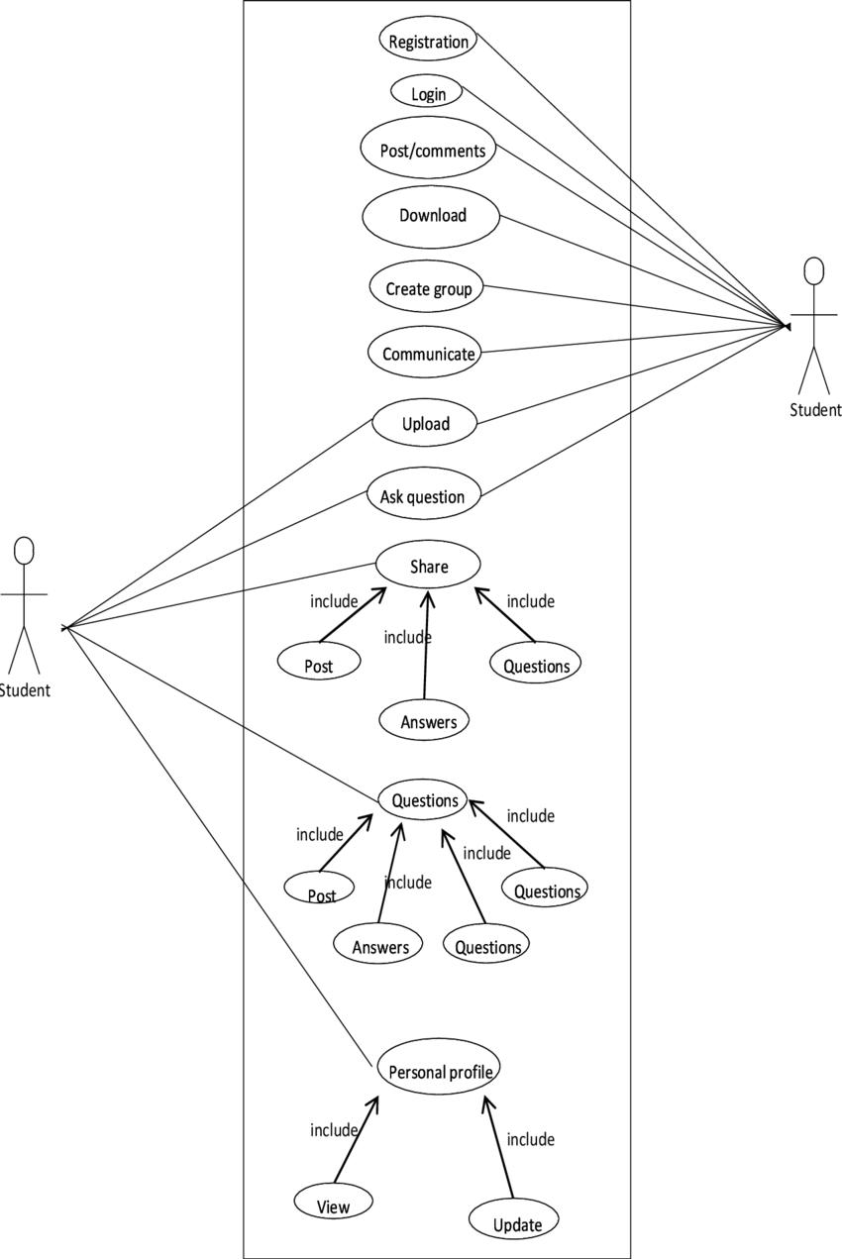

**Fig 5.1: UML diagram for E-learning and campus information system**

**5.2.2 SEQUENCE DIAGRAM**

The sequence diagram is a good diagram to use to document a system's requirements and to flush out a system's design. The reason the sequence diagram is so useful is because it shows the interaction logic between the objects in the system in the time order that the interactions take place.

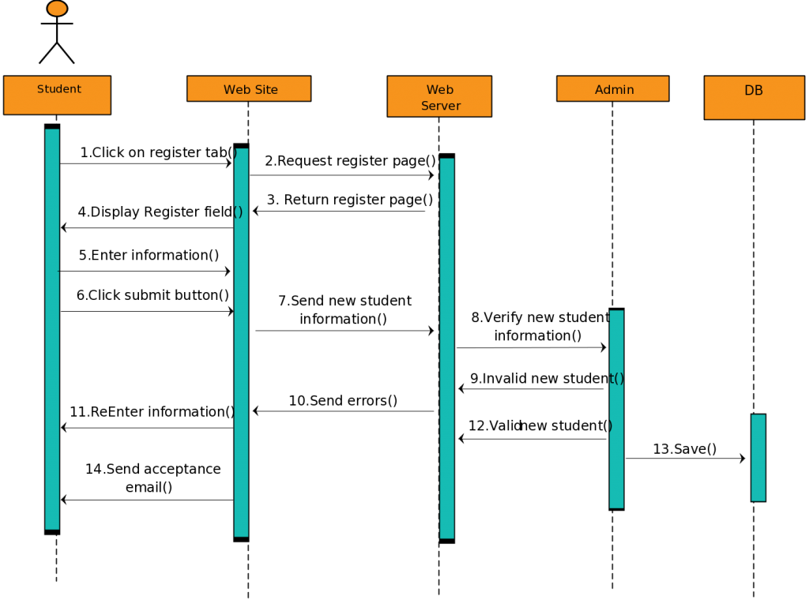

**Fig 5.2 : Sequence diagram for E-learning and campus information system**

**5.2.3 CLASS DIAGRAM**

A class diagram is an illustration of the relationships and source code dependencies among classes in the Unified Modeling Language (UML). In this context, a class defines the methods and variables in an object, which is a specific entity in a program or the unit of code representing that entity.

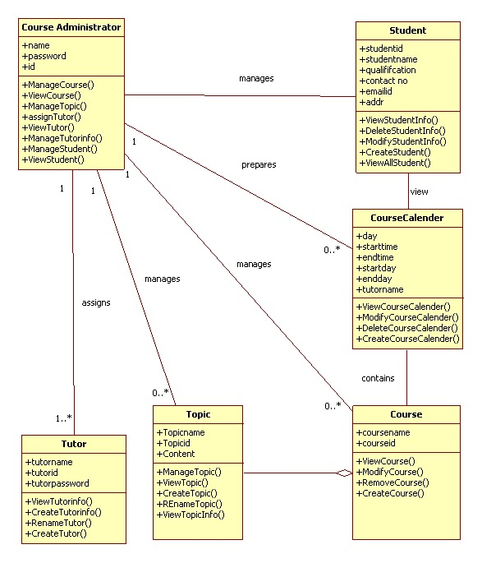

**Fig 5.3 : class diagram for E-learning and campus information system**

**5.2.4 DEPLOYMENT DIAGRAM**

Deployment diagrams are used to visualize the topology of the physical components of a system, where the software components are deployed. The term Deployment itself describes the purpose of the diagram. Deployment diagrams are used for describing the hardware components, where software components are deployed. Component diagrams and deployment.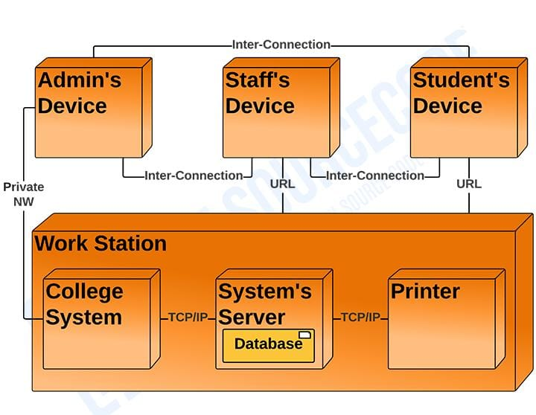

**Fig 5.4 : Deployment diagram for E-learning and campus information system**

**5.2.5 ACTIVITY DIAGRAM STAFF MODULE**

An activity diagram visually presents a series of actions or flow of control in a system similar to a flowchart or a data flow diagram. Activity diagrams are often used in business process modeling. They can also describe the steps in a use case diagram. Activities modeled can be sequential and concurrent.

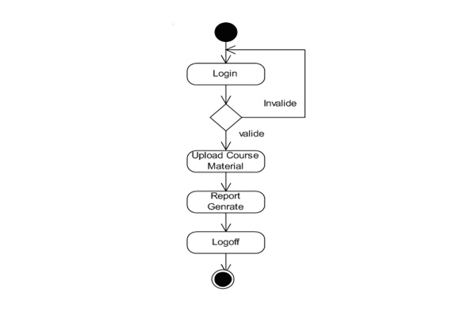

**Fig 5.5 : Activity diagram for Staff module**

**5.2.6 ACTIVITY DIAGRAM STUDENT**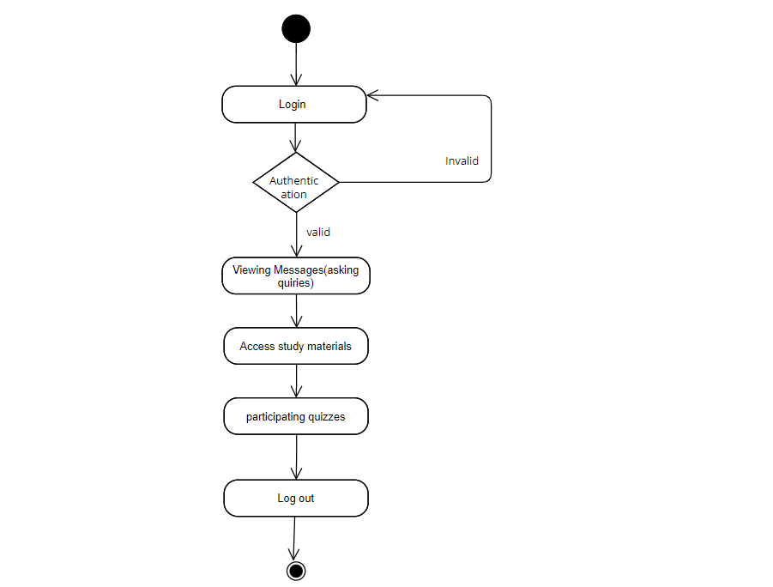

**Fig 5.6 : Activity diagram for Student module**

**CHAPTER 6**

**IMPLEMENTATION**

**6.1. IMPLEMENTATION AND MODEL**

Internet has joined the people living around the globe. It has, no doubt, gotten quite tough to sustain your identity in the cyber world as the competition has gone beyond the limits. To make it easier for you to compete and excel in the world of internet, PHP is among the best tools that can be used. PHP is abbreviation of "personal homepage" and sometimes is also known as Hypertext Pre-processor. The latter name is particularly used in the cyber circle. It is, in general, a HTML embedded scripting language being used widely for the web application development. The use of the language has increased in recent times due to the ease it offers to the developer. There are various benefits of using the language over the others developed for the same purpose. Some of the major pros pertinent to the language are discussed as under:

**Double end web development**

Some of the languages used for web development have limitation of purposes. PHP is one of its kinds because it may be used on both front-end and back-end web development. Due to this feature, a programmer may easily alter the present conditions of the website merely by changing a single code. Unlike PHP, other languages need to be uncoded to understand the correlation among the back-end and front-end languages making programming time taking and laborious.

**6.2. ABOUT PHP**

PHP started out as a small open-source project that evolved as more and more people found out how useful it was. Rasmus Lerdorf unleashed the first version of PHP way back in 1994.

* PHP is a recursive acronym for "PHP: Hypertext Pre-processor".
* PHP is a server-side scripting language that is embedded in HTML. It is used to manage dynamic content, databases, session tracking, even build entire e-commerce sites.
* It is integrated with a number of popular databases, including MySQL, PostgreSQL, Oracle, Sybase, Informix, and Microsoft SQL Server.
* PHP is pleasingly zippy in its execution, especially when compiled as an Apache module on the Unix side. The MySQL server, once started, executes even very complex queries with huge result sets in record-setting time.
* PHP supports a large number of major protocols such as POP3, IMAP, and LDAP. PHP4 added support for Java and distributed object architectures (COM and CORBA), making n-tier development a possibility for the first time.
* PHP is forgiving: PHP language tries to be as forgiving as possible.
* PHP Syntax is C-Like.

**6.2.1 COMMON USES IN PHP**

* PHP performs system functions, i.e., from files on a system it can create, open, read, write, and close them.
* PHP can handle forms, i.e., gather data from files, save data to a file, thru email you can send data, return data to the user.
* You add, delete, modify elements within your database thru PHP.
* Access cookies variables and set cookies.
* Using PHP, you can restrict users to access some pages of your website.
* It can encrypt data.

**6.2.2. PHP: BUILT IN DATABASE ACCESS**

PHP provides built-in database connectivity for a wide range of databases

– MySQL, PostgreSQL, Oracle, Berkeley DB, Informix, MySQL, Lotus Notes, and more

– Starting support for a specific database may involve PHP configuration steps

• Another advantage of using a programming language that has been designed for the creation of web apps.

• Support for each database is described in the PHP manual at:

– http://www.php.net/manual/en/ MySQL and PHP

• To connect to a database, need to create a connection

– At lowest level, this is a network connection

– Involves a login sequence (username/password

• Since this is a relatively expensive step, web application environments:

– Share connections

– Have multiple connections

• Whether, and how many, are typical configuration items. In MySQL:

– Allow persistent: whether to allow persistent connections

– Max persistent: the maximum number of persistent connections

– Max links: max number of connections, persistent and not

– Connection timeout: how long the persistent connection is left open

**6.2.3. CREATING DATABASE CONNECTIONS**

• Use either MySQL connect or mysql_pconnect to create database connection

– MySQL connect: connection is closed at end of script (end of page)

– mysql_pconnect: creates persistent connection

• connection remains even after end of the page

• Parameters

– Server – hostname of server

– Username – username on the database

– Password – password on the database

– New Link (MySQL connect only) – reuse database connection created by previous call to mysql_connect

– Client Flags

• MYSQL_CLIENT_SSL:: Use SSL

• MYSQL_CLIENT_COMPRESS:: Compress data sent to MySQL

**Security Note**

• Username and password fields imply that database password is sitting there in the source code If someone gains access to source code, can compromise the database

– Servers are sometimes configured to view PHP source code when a resource is requested with “. phps” instead of “.php”

– One approach to avoid this: put this information in Web server config. File

• Then ensure the Web server config. file is not externally accessible

**Selecting a Database**

• mysql_select_db ()

– Pass it the database name

• Related:

– mysql_list_dbs ()

• List databases available

– Mysql_list_tables ()

• List database tables available

**Perform SQL Query**

• Create query string

– $query = ‘SQL formatted string’

– $query = ‘SELECT * FROM table’

• Submit query to database for processing

– $result = MySQL query($query);

– For UPDATE, DELETE, DROP, etc, returns TRUE or FALSE

– For SELECT, SHOW, DESCRIBE or EXPLAIN, $result is an identifier for the results, and does not contain the results themselves

• $result is called a “resource” in this case

• A result of FALSE indicates an error

• If there is an error

– MySQL error () returns error string from last MySQL call

**Process Results**

• Many functions exist to work with database results

• mysql_num_rows ()

– Number of rows in the result set

– Useful for iterating over result set

• mysql_fetch_array ()

– Returns a result row as an array

– Can be associative or numeric or both (default)

– $row = mysql_fetch_array($result);

– $row [‘column name’] :: value comes from database row with specified column name

– $row [0] :: value comes from first field in result set

**Process Results Loop**

• Easy loop for processing results:

$result = mysql_query($qstring);

$num_rows = mysql_num_rows($result);

for ($i=0; $I<$num_rows;$i++){

$row = mysql_fetch_array($result);

// take action on database results here

}

**6.3. OUTPUT SCREEN SHOTS:**



**Snapshot 6.1 : Home Page**



**Snapshot 6.2 : Campus Information**

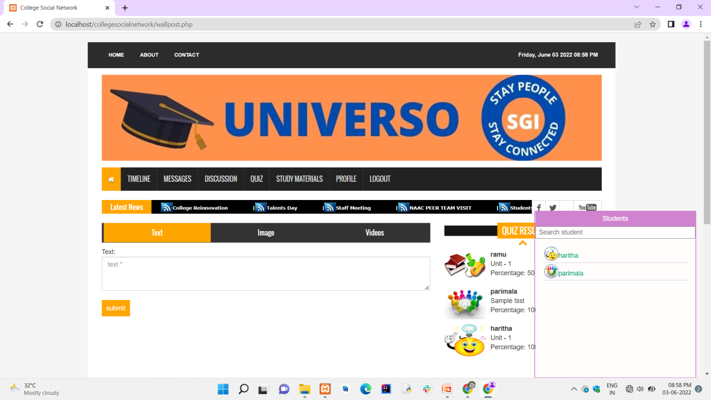

**Snapshot 6.3 : Student page**

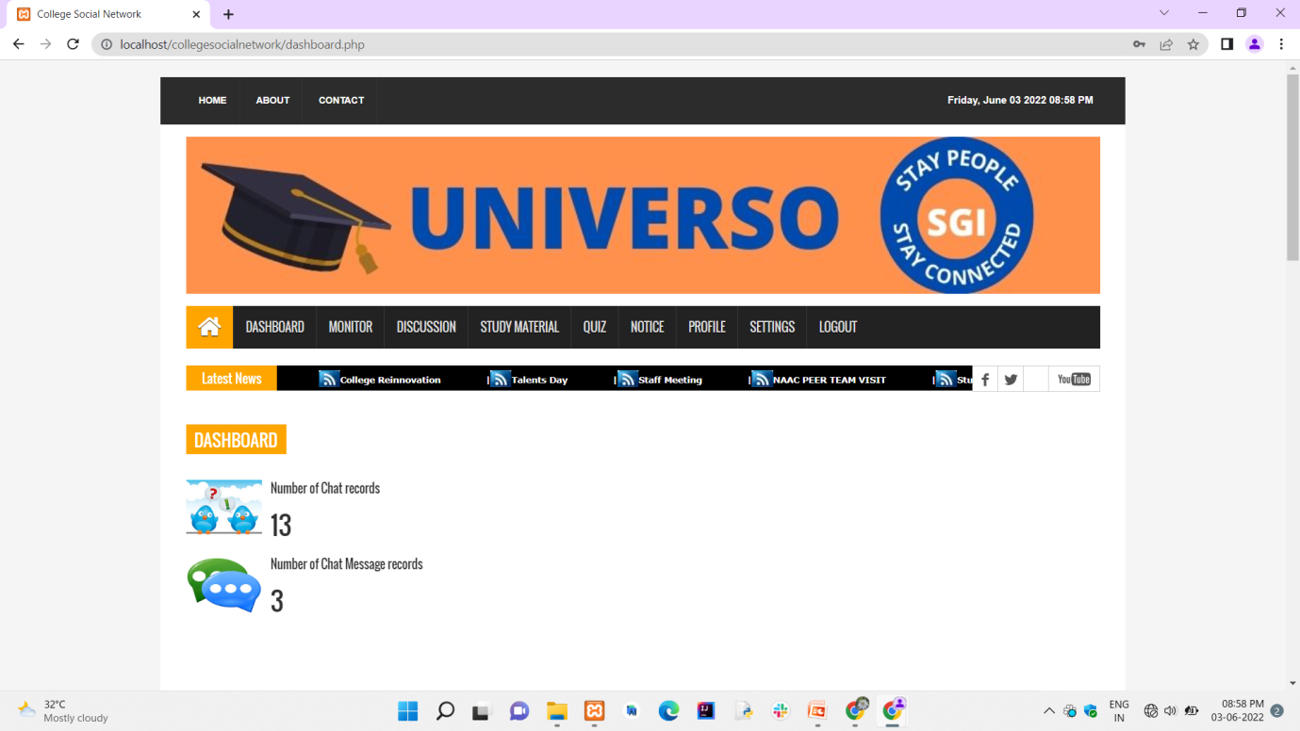

**Snapshot 6.5 : Admin dashboard**

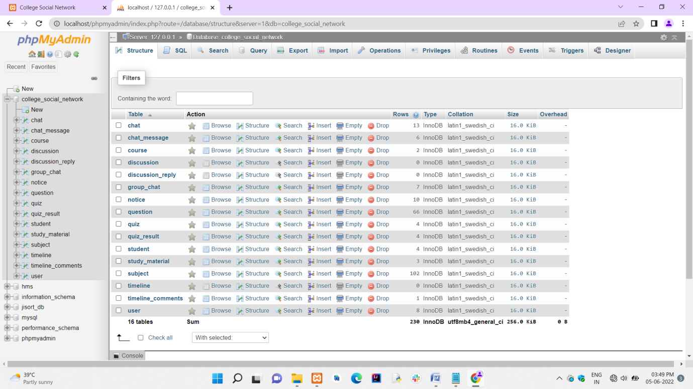

**Snapshot 6.6 : Database**

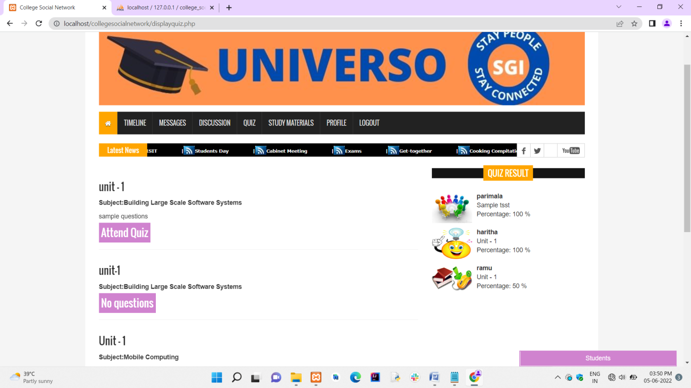

**Snapshot 6.7 : Accessing quiz**

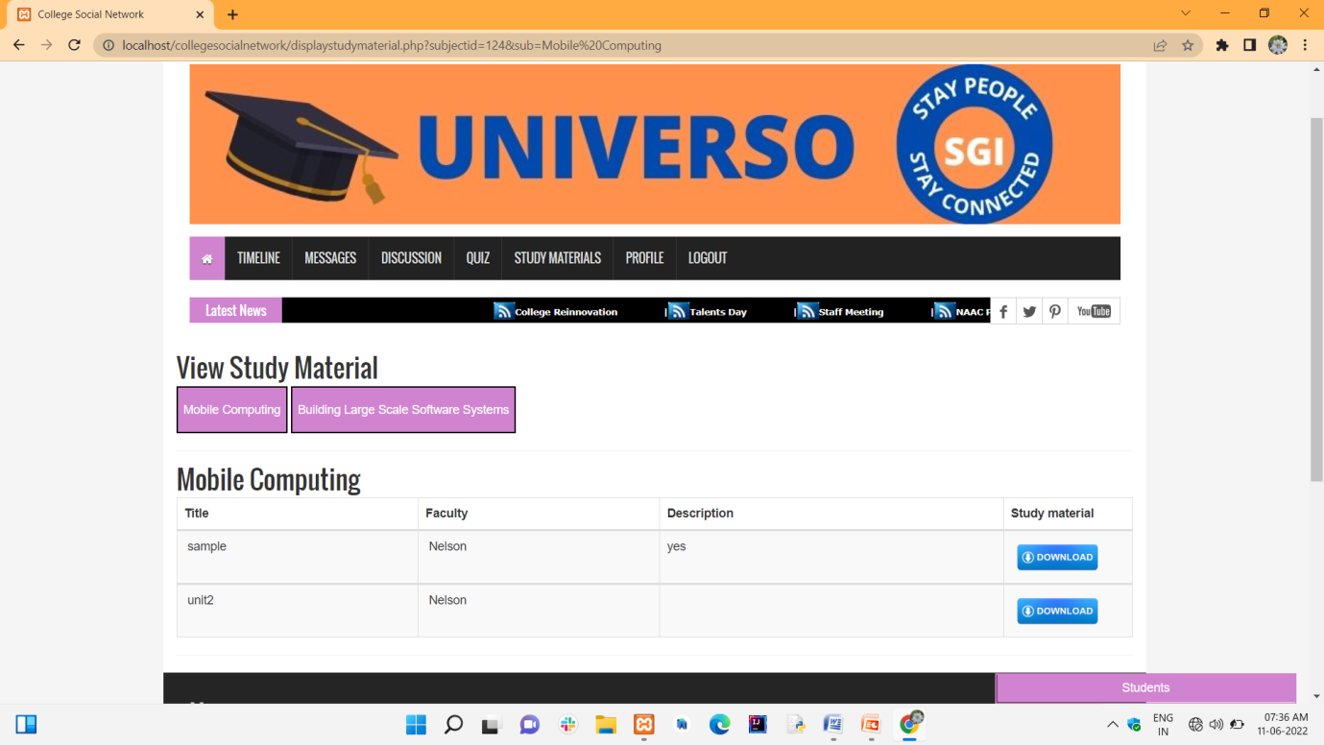

**Snapshot 6.8 : Study Materials download**

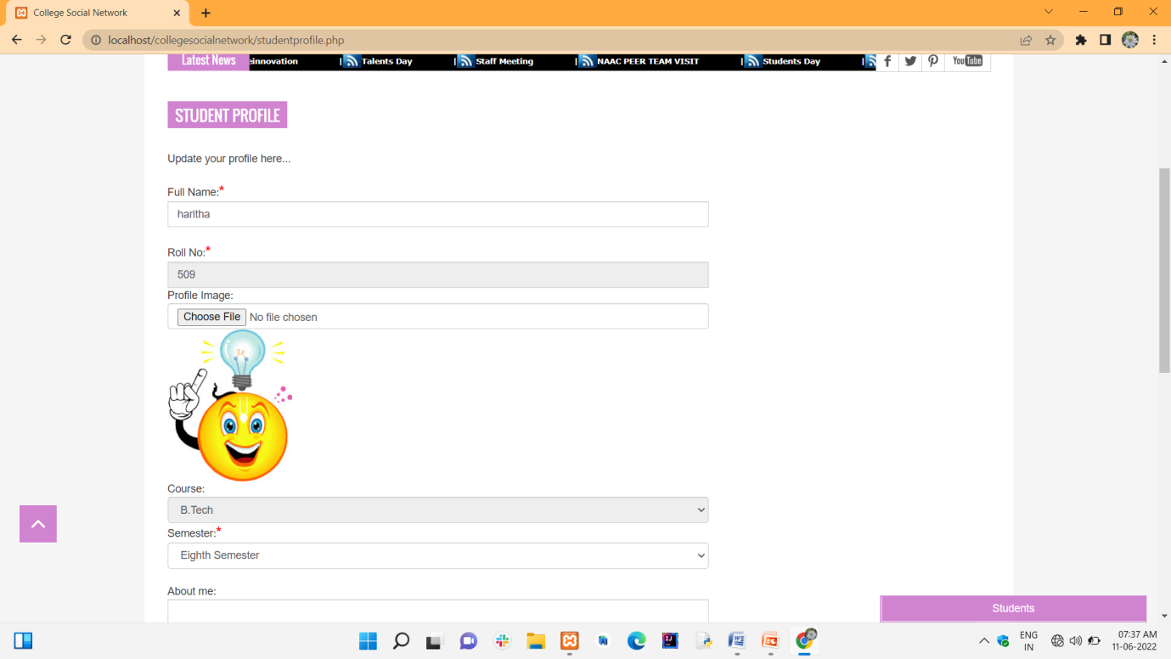

**Snapshot 6.9 : Student Profile**

## CHAPTER 7

## TESTING

**7.1. SYSTEM TESTING**

The purpose of testing is to discover errors. Testing is the process of trying to discover every conceivable fault or weakness in a work product. It provides a way to check the functionality of components, sub-assemblies, assemblies and/or a finished product It is the process of exercising software with the intent of ensuring that the Software system meets its requirements and user expectations and does not fail in an unacceptable manner. There are various types of tests. Each test type addresses a specific testing requirement.

**7.2. TYPES OF TESTING**

**7.2.1 Unit Testing**

Unit testing involves the design of test cases that validate that the internal program logic is functioning properly, and that program inputs produce valid outputs. All decision branches and internal code flow should be validated. It is the testing of individual software units of the application .it is done after the completion of an individual unit before integration. This is a structural testing, that relies on knowledge of its construction and is invasive. Unit tests perform basic tests at component level and test a specific business process, application, and/or system configuration. Unit tests ensure that each unique path of a business process performs accurately to the documented specifications and contains clearly defined inputs and expected results.

**7.2.2 INTEGRATION TESTING**

Integration tests are designed to test integrated software components to determine if they actually run as one program. Testing is event driven and is more concerned with the basic outcome of screens or fields. Integration tests demonstrate that although the components were individually satisfaction, as shown by successfully unit testing, the combination of components is correct and consistent. Integration testing is specifically aimed at exposing the problems that arise from the combination of components.

**7.2.3 Functional Test**

Functional tests provide systematic demonstrations that functions tested are available as specified by the business and technical requirements, system documentation, and user manuals.

Functional testing is centered on the following items:

Valid Input : identified classes of valid input must be accepted.

Invalid Input : identified classes of invalid input must be rejected.

Functions : identified functions must be exercised.

Output : identified classes of application outputs must be exercised.

Systems/Procedures: interfacing systems or procedures must be invoked. Organization and preparation of functional tests is focused on requirements, key functions, or special test cases. In addition, systematic coverage pertaining to identify Business process flows; data fields, predefined processes, and successive processes must be considered for testing. Before functional testing is complete, additional tests are identified and the effective value of current tests is determined.

**7.2.4 SYSTEM TEST**

System testing ensures that the entire integrated software system meets requirements. It tests a configuration to ensure known and predictable results. An example of system testing is the configuration-oriented system integration test. System testing is based on process descriptions and flows, emphasizing pre-driven process links and integration points.

**7.2.5 WHITE BOX TESTING**

White Box Testing is a testing in which in which the software tester has knowledge of the inner workings, structure and language of the software, or at least its purpose. It is purpose. It is used to test areas that cannot be reached from a black box level.

**7.2.6 BLACK BOX TESTING**

Black Box Testing is testing the software without any knowledge of the inner workings, structure or language of the module being tested. Black box tests, as most other kinds of tests, must be written from a definitive source document, such as specification or requirements document, such as specification or requirements document. It is a testing in which the software under test is treated, as a black box. you cannot “see” into it. The test provides inputs and responds to outputs without considering how the software works.

**7.3.UNIT TESTING**

Unit testing is usually conducted as part of a combined code and unit test phase of the software lifecycle, although it is not uncommon for coding and unit testing to be conducted as two distinct phases.

**Test strategy and approach**

Field testing will be performed manually and functional tests will be written in detail.

**Test objectives**

* All field entries must work properly.
* Pages must be activated from the identified link.
* The entry screen, messages and responses must not be delayed.

**Features to be tested**

* Verify that the entries are of the correct format
* No duplicate entries should be allowed
* All links should take the user to the correct page.

**7.4. INTEGRATED TESTING**

Software integration testing is the incremental integration testing of two or more integrated software components on a single platform to produce failures caused by interface defects.

The task of the integration test is to check that components or software applications, e.g., components in a software system or – one step up – software applications at the company level – interact without error.

**Test Results:** All the test cases mentioned above passed successfully. No defects encountered.

**Acceptance Testing**

User Acceptance Testing is a critical phase of any project and requires significant participation by the end user. It also ensures that the system meets the functional requirements.

**Test Results:** All the test cases mentioned above passed successfully. No defects encountered.

**CONCLUSION AND FUTURE ENHANCEMENT**

The project work titled “E-Learning and Campus Information System” has been designed using PHP – Hypertext Pre Processor where in many user friendly form controls have been added in order to make it a user interactive application. The system is developed in such a way that the user with common knowledge of computers can handle it easily. This website makes it easy for the Sanskrithi school College to interact with their staffs and students in single platform.

It was a wonderful learning experience while working on this project. This project took us through the various phases of project development and gave us real insight into the world of software designing. The joy of working and the thrill involved while tackling the various problems and challenges gave us a feel of developer’s industry.

It was due to the project we came to know how professional software’s are designed. The future enhancements to the system can be made as technology changes.

**FUTURE SCOPE**

This project can be easily implemented under various situations. We can add new features as and when we require. Reusability is possible as and when require in this project. There is flexibility al lathe modules. The system can have following changes in future:

* + - To add study materials
    - To conduct quizzes
    - To add new courses
    - Communicating students one to one
    - Subject wise Student Discussion
    - To publish notices

**REFERENCES**

1. 1 Ibrhaim Al-Oqily, Emad Abdallah and Alaa Abdallah developed on "Mobile Intra- Campus Student Social Network". IEEE paper published on 2019.
2. Dr.Mohammedyahya Alghamdi developed on "A study of Social Network Applications". IEEE paper published on 2020.
3. Dr. Vineeth singh developed on "Android Based Student Learning System". IEEE paper published on
4. Dr. R. Subraman developed on "Academic usage of Social Networking Sites". IEEE paper published on 2019.
5. Dr. Prabhu T Kannan, Sri vidya developed on "A Student Information system". IEEE paper published on 2018
6. Moodle. What is Moodle? Retrieved September 3, 2013, from https://mooodle.org [3].
7. Trifonova, Anna (2003). Mobile Learning – Review of The Literature .University of Trento, Italy.
8. Buabeng-Andoh, C. (2012) “Factors Infuencing Teachers’ Adoption and Integration of Information and Communication Technology (ICT) into teaching: A Review of the Literature” International Journal of Education and Development using Information and Communication Technology, Vol. 8, Issue 1, pp. 136-155.
9. Attewell, J. (2005). “Mobile technologies and learning [Electronic Version]”. A technology update and mlearningproject summary, Technology Enhanced Learning Research Centre, Learning and Skills Development Agency.

**APPENDIX-II**

**SOURCE CODE**

**INDEX.PHP :**

<?php

include("header.php");

//Codings of Meeting

$sqlmaxmeeting ="SELECT max(notice_id) FROM notice WHERE notice_type='Meeting' ";

$qsqlmaxmeeting = mysqli_query($con, $sqlmaxmeeting);

$rsrecmaxmeeting = mysqli_fetch_array($qsqlmaxmeeting);

$sqlnoticemeeting ="SELECT * FROM notice WHERE notice_id='$rsrecmaxmeeting[0]'";

$qsqlnoticemeeting = mysqli_query($con, $sqlnoticemeeting);

$rsrecnoticemeeting = mysqli_fetch_array($qsqlnoticemeeting);

//Codings of Meeting ends here

//Codings of News

$sqlmaxnews ="SELECT max(notice_id) FROM notice WHERE notice_type='News and Updates' ";

$qsqlmaxnews = mysqli_query($con, $sqlmaxnews);

$rsrecmaxnews = mysqli_fetch_array($qsqlmaxnews);

$sqlnoticenews ="SELECT * FROM notice WHERE notice_id='$rsrecmaxnews[0]'";

$qsqlnoticenews = mysqli_query($con, $sqlnoticenews);

$rsrecnoticenews = mysqli_fetch_array($qsqlnoticenews);

//Codings of News ends here

//Codings of Events

$sqlmaxevents ="SELECT max(notice_id) FROM notice WHERE notice_type='Events' ";

$qsqlmaxevents = mysqli_query($con, $sqlmaxevents);

$rsrecmaxevents = mysqli_fetch_array($qsqlmaxevents);

$sqlnoticeevents ="SELECT * FROM notice WHERE notice_id='$rsrecmaxevents[0]'";

$qsqlnoticeevents = mysqli_query($con, $sqlnoticeevents);

$rsrecnoticeevents = mysqli_fetch_array($qsqlnoticeevents);

//Codings of Events ends here

?>

<section id="sliderSection">

<div class="row">

<div class="col-lg-8 col-md-8 col-sm-8">

<div class="slick_slider">

**QUIZ.PHP :**

<?php

include("header.php");

if($_SESSION['sessionid'] == $_POST['sessionid'])

{

if(isset($_POST['submit']))

{

$title= mysqli_real_escape_string($con, $_POST['title']);

$description= mysqli_real_escape_string($con, $_POST['description']);

if(isset($_GET['editid']))

{

$sql="UPDATE quiz set course_id='$_POST[course]',semester='$_POST[semester]',subject_id='$_POST[subject]',title='$title',description='$description' WHERE quiz_id='$_GET[editid]'";

$qsql = mysqli_query($con,$sql);

if(!$qsql)

{

echo mysqli_error($con);

}

if(mysqli_affected_rows($con) == 1)

{

echo "<SCRIPT>alert('Quiz record UPDATED successfully..');</SCRIPT>";

echo "<script>window.location='viewquiz.php';</script>";

}

}

else

{

$sql="INSERT INTO quiz(user_id,course_id,semester,subject_id,title,description) values ('$_SESSION[user_id]','$_POST[course]','$_POST[semester]','$_POST[subject]','$_POST[title]','$description')";

$qsql = mysqli_query($con,$sql);

if(!$qsql)

{

echo mysqli_error($con);

}

if(mysqli_affected_rows($con) == 1)

{ echo "<SCRIPT>alert('Quiz record inserted successfully..');</SCRIPT>";

echo "<script>window.location='viewquiz.php';</script>";

}

}

}

**NOTICES.PHP :**

<?php

include("header.php");

if(!isset($_SESSION['user_id']))

{

echo "<script>window.location='userlogin.php';</script>";

}

if($_SESSION['sessionid'] == $_POST['sessionid'])

{

if($_FILES["uploadfile"]["name"] != "")

{

$imgname = rand(). $_FILES["uploadfile"]["name"];

move_uploaded_file($_FILES["uploadfile"]["tmp_name"],"noticeimages/".$imgname);

}

if(isset($_POST['submit']))

{

$title= mysqli_real_escape_string($con, $_POST['title']);

$description= mysqli_real_escape_string($con, $_POST['description']);

if(isset($_GET['editid']))

{

$sql="UPDATE notice set notice_type='$_POST[noticetype]',user_id='$_POST[user]',title='$title',description='$description',";

if($_FILES["uploadfile"]["name"] != "")

{

$sql = $sql . "uploads='$imgname',";

}

$sql = $sql .

"date_time='$dt $tim',status='Active' WHERE notice_id='$_GET[editid]'";

$qsql = mysqli_query($con,$sql);

if(!$qsql)

{

echo mysqli_error($con);

}

if(mysqli_affected_rows($con) == 1)

{

echo "<SCRIPT>alert('Notice record UPDATED successfully..');</SCRIPT>";

echo "<script>window.location='viewnotice.php';</script>";

}

}

else

{

$sql="INSERT INTO notice(notice_type,user_id,title,description,uploads,date_time,status) values ('$_POST[noticetype]','$_SESSION[user_id]','$title','$description','$imgname','$dt $tim','Active')";

$qsql = mysqli_query($con,$sql);

if(!$qsql)

{

echo mysqli_error($con);

}

if(mysqli_affected_rows($con) == 1)

{

echo "<SCRIPT>alert('Notice record inserted successfully.');</SCRIPT>";

echo "<script>window.location='viewnotice.php';</script>";

}

}

}

}

$_SESSION['sessionid'] = rand();

if(isset($_GET['editid']))

{

$sqledit = "SELECT * FROM notice WHERE notice_id='$_GET[editid]'";

$qsqledit = mysqli_query($con,$sqledit);

$rsedit = mysqli_fetch_array($qsqledit);

}

?>

<section id="contentSection">

<div class="row">

<div class="col-lg-8 col-md-8 col-sm-8">

<div class="left_content">

<div class="contact_area">

<h2>Publish Notice here</h2>

<p>Add your notice.</p>

<form action="" class="contact_form" method="post" enctype="multipart/form-data" name="frmnotice" onsubmit="return validateform()">

<input type="hidden" name="sessionid" value="<?php echo $_SESSION['sessionid']; ?>" >

Notice Type:<font color='red' size='4'><strong>*</strong></font>

<select name="noticetype" class="form-control" tabindex="1" autofocus="autofocus">

<option value="">Select</option>

<?php

$arr = array("Events","Meeting","News and Updates");

foreach($arr as $val)

{

if($val == $rsedit['notice_type'])

{

echo "<option vaulue='$val' selected>$val</option>";

}

else

{

echo "<option value='$val'>$val</option>";

}

}

?>

</select>

<span id="idnoticetype"></span>

<br />

Title:<font color='red' size='4'><strong>*</strong></font>

<input type="text" name="title" class="form-control" placeholder="title *" value="<?php echo $rsedit['title']; ?>" tabindex="2">

<span id="idtitle"></span>

<br />

Description<font color='red' size='4'><strong>*</strong></font>:

<script src="richtexteditor/tinymce.min.js"></script>

<script>tinymce.init({ selector:'textarea' });</script>

<textarea name="description" id="descriptions" class="form-control" cols="30" rows="10" placeholder="description *" tabindex="3"><p><?php

if(isset($_GET['editid']))

{

echo strip_tags(substr($rsedit['description'], 0, 50000));

}

?></p></textarea>

<span id="iddescription"></span>

<br />

Upload Image:

<input type="file" name="uploadfile" class="form-control" value="<?php echo $rsedit['uploads']; ?>" accept="image/*" onchange="loadFile(event)" tabindex="4">

<?php

if($rsedit['uploads'] == "")

{

echo '<imgsrc="images/no-image.png" height="200" alt="Image preview..." id="previewimg">';

}

else

{

echo "<imgsrc='noticeimages/$rsedit[uploads]' height='200' alt='Image preview...' id='previewimg'>";

}

?>

<br />

<br />

<input name="submit" type="submit" value="submit">

</form>

</div>

</div>

</div>

</div>

</section>

<?php

include("footer.php")

?>

<script>

var loadFile = function(event) {

var reader = new FileReader();

reader.onload = function(){

var output = document.getElementById('previewimg');

output.src = reader.result;

};

reader.readAsDataURL(event.target.files[0]);

};

</script>

<script type="application/javascript">

function validateform()

{

var validatecondtion = 0;

document.getElementById("idnoticetype").innerHTML ="";

document.getElementById("idtitle").innerHTML ="";document.getElementById("iddescription").innerHTML ="";

if(document.frmnotice.noticetype.value=="")

{

document.getElementById("idnoticetype").innerHTML ="<font color='red'>Kindly select Notice type..</font>";

validatecondtion=1;

}

</script>

**USE LOGIN.PHP :**

<?php

include("header.php");

if(isset($_SESSION['user_id']))

{

echo "<script>window.location='dashboard.php';</script>";

}

if(isset($_POST['submit']))

{

$ectpass=md5($_POST['password']);

$sql = "SELECT * FROM user WHERE login_id='$_POST[loginid]' AND password='$ectpass' AND status='Active'";

$qsql = mysqli_query($con,$sql);

if(!$qsql)

{

echo mysqli_error($con);

}

if(mysqli_num_rows($qsql) == 1)

{

$rs = mysqli_fetch_array($qsql);

$_SESSION['user_id'] = $rs['user_id'];

$_SESSION['user_type'] = $rs['user_type'];

echo "<script>window.location='dashboard.php';</script>";

}

else

{

$msg = "<p><font color='red'><strong>Invalid Login ID and password entered..</strong></font></p>";

}

}

?>

<section id="contentSection">

<div class="row">

<div class="col-lg-8 col-md-8 col-sm-8">

<div class="left_content">

<div class="contact_area">

<h2>Staff Login Panel</h2>

<p>Login into your account.</p>

<p><font color='red'><strong><?php echo $msg; ?></strong></font></ p>

<form action="" class="contact_form" method="post" name="frmuserlogin" onsubmit="return validateform()">

<span id="idusertype"></span>

<br>

Login ID:<font color='red' size='4'><strong>*</strong></font>

<input name="loginid" class="form-control" type="text" placeholder="Login ID *">

<span id="idloginid"></span>

<br>

Password:<font color='red' size='4'><strong>*</strong></font>

<input name="password" class="form-control" type="password" placeholder="Password *">

<span id="idpassword"></span>

<br>

<br>

<input name="submit" type="submit" value="Login">

</form>

</div>

</div>

</div>

</div>

</section>

<?php

include("footer.php")

?>

<script type="application/javascript">

function validateform()

{

var alphaExp = /^[a-zA-Z]+$/; //Variable to validate only alphabets

var alphaspaceExp = /^[a-zA-Z\s]+$/; //Variable to validate only alphabets and space

**APPENDIX-III**

International Journal of Research Publication and Reviews, Vol 3, Issue 6, pp 2311-2313, June 2022

**International Journal of Research Publication and Reviews**

Journal homepage: www.ijrpr.com ISSN 2582-7421

**“E-LEARNING AND CAMPUS INFORMATION SYSTEM”**

O. Bhaskar a, K. Uday b, K. Parimala c, B. Haritha d, K. Sai joshna e, N. Vijaya sai f

aAssistant Professor, Department of Computer Science and Engineering, Sanskrtihi School of Engineering, Puttaparthy, Andra pradesh, India

b B.Tech Student,Department of Computer Science and Engineering, Sanskrtihi School of Engineering, Puttaparthy, Andra pradesh, India

c B.Tech Student,Department of Computer Science and Engineering, Sanskrtihi School of Engineering, Puttaparthy, Andra pradesh, India

d B.Tech Student,Department of Computer Science and Engineering, Sanskrtihi School of Engineering, Puttaparthy, Andra pradesh, India

e B.Tech Student,Department of Computer Science and Engineering, Sanskrtihi School of Engineering, Puttaparthy, Andra pradesh, Indiaf B.Tech Student,Department of Computer Science and Engineering, Sanskrtihi School of Engineering, Puttaparthy, Andra pradesh, India

**ABSTRACT:**



New services have arisen in the last decade as the use of the internet has grown. Several studies have revealed that university college pupils are relying on these newly developed sciences to amass fantastic responsibilities. The purpose of this internet site is to pr ovide a single platform for university college students and team members to engage with one another, including discussing their questions, uploading study materials, handling a leaflet, and praying for him so that he may be saved. Their messages, photos, and videos appear on their timelines as a result of seeing n otifications distributed by coworkers. The web page administrator is in charge of operations such as adding and removing courses, materials, university students and employees, and posting articles.



***Keywords****: uploading materials, conducting quizzes, tracking activities.*



1. **INTRODUCTION**

E-learning is an organized course or learning experience delivered electronically with performance support content. A learning management sys-tem is commonly used to manage and administer online courses. This site's administrator is in charge of tasks including adding and removing courses, subjects, students, and staff members, as well as issuing notices. The contact information for the college management system is provided by this appli-cation.

You can include some additional features such as direct interaction with faculty to clear their doubts through a chat system, and students can download documents. Online study materials can be uploaded by faculties. Faculty members can upload study materials for students to see. The administrator has complete control over the website, which must be kept up to date in the database for various options. Students can speak with their professors individu-ally or in groups using the project's individual and group chat features.

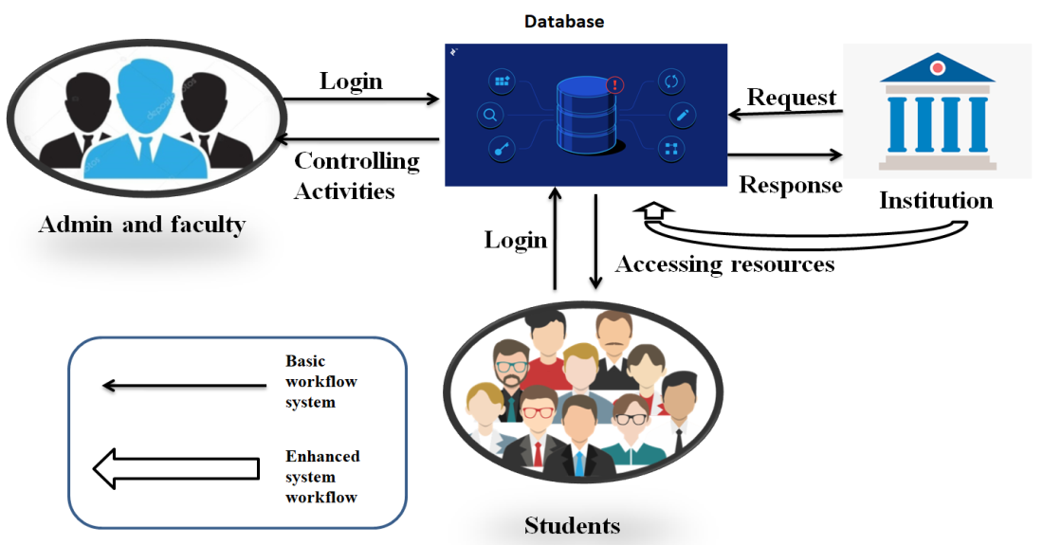

Fig. 1 – Block diagram for E-Learning and campus information system

**1.1 Designing Detail Block diagram :** The goal is superior within the net-based absolutely completely procedure, and it can suggest numerous features inside the extraordinary sub modules. It is linked to different social media and has more information on university college students' criteria. The most important thing is to connect modules with submodules so that we can comprehend everything in a short amount of time. Social networking is a fantastic way to meet interesting people on campus. Previously, this was done in a utility format. As a result, dealing with the modules within a single database is difficult. The web-based entirely absolutely method is simple to implement and useful.

a. Admin and staff module

b. Student module

c. Campus information module

1.1.1 Admin module :

In this project, the admin plays a crucial function. The administrator will use a username and pass-word to log in to this module. Previously, the ad-min was as soon as the login internet internet web page included Keeping track of the tasks and records of university students and team members. The display panel in the admin module can be used to check student discussions.

1.1.2. Staff module :

Staff will be responsible for adding the test chemicals and completing the quizzes. Within the upload challenge fields, add the themes to the semester. Students are raising concerns about challenge-related questions, and the college is responding.

1.1.3. Student module :

Here withinside the scholar module first college university college students select out to signal in them self to go into into the portal. Student choice to go into man or woman name, password, e mail whole the registration form. After ending the method of registration scholar can login in to the portal with the resource of the usage of manner of the use of the man or woman identification and password. Student can signal in absolutely one time to go into in to the portal. After of of entirety of login way pupil to speak with university mates. Students have crew chat to talk about with their queries in that panel. Regarding venture associated questions to talk about with one after the contrary to the colleges and in addition to get admission to the quizzes , discover out about substances withinside the panel.

1.1.4. Campus information Module :

In this students to see latest updates about college and also to see the college information in the about us page. If any queries means directly mail to the college staffs.

1. Methodology

The project developed in the web based mechanism and it shows many functionalities in the different sub modules. It is related other social media and its contain extra features about students criteria. Main things to connect modules with sub modules, with this we can know all the things in short time. Social media is one of the best source to connect with different peoples in the college website. In previous methodologies this is is implemented in application format. In that the modules difficult to handle in the single database. The webs based methodology is easy to implement and its simple to use all services. Performance is very effective in the web based platform. E-leaning method is perfect way to implement in online platform and its ac-cess to the students interface of the website.



1. **IMPLEMENTATION**

Quality implantation plays an important role in success of the project. The E-learning and campus information system is an web application based project which helps colleges to deal with the placements. The three modules of e-learning and campus information system as follows Admin module, Staff module, Student module.

* Fulfillment of this web application done by using Html and CSS for front end and Php as back end.
* Various tools required to implement this project.
* Visual studio 2013(Php tools installed)
* XAMPP (Apache server and MYSQL to store the data)
* Visual studio is used to edit the code and to test the PHP files we need to use Apache server to display php code output on browser ,and the source code store in XAMPP>htdocs>www folder.

**ABOUT MODULES:**

**Admin Module:** Admin performs crucial position on this project. In this module the admin will login via way of means of the usage of username and password. Once the admin turned into login net web page consists of Tracking the sports of the scholars and body of workers records. Student discus-sions to checking with assist of screen panel withinside the admin module.

**Staff Module:** Staff to upload the study materials and conducting quizzes. To add the subjects into the semester in the add subject fields. Students is asking doubts regarding subject related questions, In this the faculty to answering the questions. **Student Module:** Here within side the pupil module first university college students favour to sign up them self to go into into the portal. Student opt to input patron name, password, e-mail entire the registration form. After finishing the technique of registration pupil can login in to the portal via using the individual identification and password. Student can sign up entirely one time to go into in to the portal. After of entirety login way people to talk with college mates. Students have group chat to speak approximately with their queries in that panel. Regarding issue related questions to speak ap-proximately with one after the other to the faculties and moreover to get right of entry to the quizzes , discover approximat ely materials within side the panel.

**Campus information Module:** In this students to see latest updates about college and also to see the college information in the about us page. If any queries means directly mail to the college staffs.



1. **PROPOSED STUDY**

We studied extensive in previous papers. In that university college students speak with their every day activiti es. We are offering campus infor-mation and timeline notices within side the application. Admin to manipulate the all activities within side the application. Students have permission to access the discover approximately materials and quizzes within side the panel. In each degree they have got a permission to speak approximately trou-ble related questions. Different modules for student communicate within side the software

**Advantages:**

* + The faculties can upload study materials through online.
  + Notices to provide in the timelines bar.
  + Students to access the study materials and quizzes in the panel.
  + In the application to provides the contact information for college management.

1. **CONCLUSION**



Increasing want of consolation and consisting of all of the information at one location has usually been a tough system for each person By enforc-ing this portal we suppose we are able to make the lives of college students and management a bit less difficult with the aid of using offering an oppor-tunity for the modern-day machine being used. This portal enables in control of diverse responsibilities associated with the daily sports of pupil queries.

**REFERENCES**



[1] J.K Ibrhaing Al-Oqily,G.E Mmad Abdallahih and N.Alaah Abdallah evolved on " Mobile IntraCampus Student Social Network". paper posted on 2019. International Journal and Development the use of Information and Communication Technology,Vol. 6, Issue 1,pp. 126-155.

1. Dr.Y. Mohammedhi yahyaji Alghamdiji developed on" A study of Social Network Applications". Published on 2020. International Journal of Education and Development Information and Communication Technology,Vol. 1, Issue 1,pp. 96 - 100.
2. Dr.B. Vineethji singhar evolved on "Android Based Student Learning System”. Paper posted on 2020. International Journal of Education and Development the usage of Information Communication Technology, Vol. 6, Issue 1, pp. 193-200.
3. Dr. K. Subramanji evolved on "Academic utilization of Social Networking Sites". Paper posted on 2019. International Journal o f Education Development the usage of Information and Communication Technology, Vol. 9, Issue 2, pp. 156-159.
4. Dr.S. Prabhuji G Kannanhi, Sri kanakaji vidyafi evolved on "A Student Information system". Paper posted on 2018 . International Journal of Education and Development the usage of Information and Communication Technology, Vol. 9, Issue 4, pp. 123-128.
5. J.K.N Buabng-Andohji, C. (2012) “Factors Infuencing Teachers” Adoption and Integration of Information and Communication Technology (ICT) into teaching: A Review of the Literature” International Journal and Development the usage of Information and Communication Technology, Vol. 8, Issue 1, pp. 136-155.
6. Attewellji M.J. (2005). “Mobile technology and mastering [Electronic Version]”. A generation replace and m mastering challeng e summary, Technology Enhanced Learning Research Centre, Learning and Skills Development Agency. International Journal of Education the use of Information and Communication Technology, Vol. 0, Issue 1, pp. 190-192.
7. Moodle. What is Moodle? Retrieved September 3, 2013, from https://mooodle.org..